REPORT CARD
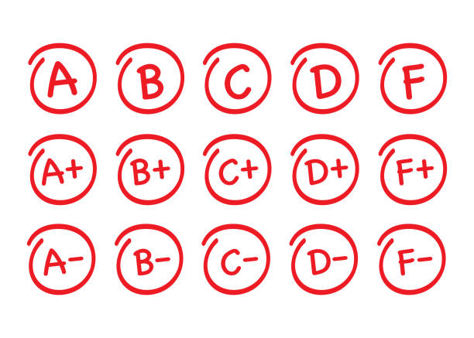
Partial Evaluation: 1
March 1st, 2022 (Spring)

NAME: Hernández Cid Armando
CLASS: 1AV

I hereby state that I got a(n)
10 (TEN) in English.

